**Lec 01**

* Definitions
* Axioms
* Theorems
  + Definitions establish the logic of probability theory.
  + Axioms are facts that we **accepts without proof**.
  + Theorems are consequences of definitions and axioms.
* **Set:** Collection of things

Ex) How to define a set with elements



* Some sets have infinite number of elements.

**Elements**: The things that together make up the set

: 1 is element of set 

* **Subset:** describes a relationship between two sets.

Ex)

If all members of set  is members of set  then  ( is subset of)

Set equality: 

 if and only if  and 

* 
* **Universal set **
* Set of all things that we could possibly consider in a given context.
* Every set is a subset of universal set.
* **Elements**
* **Null set **
  + Has no elements
  + Subset of every set.
* Union
* Intersection
* Complement

Let’s use Venn diagram to display relationships among sets.



























 





* + Disjoint if there are two sets with 
  + Mutually exclusive if there are more than two sets.

Ex]

This problem was pulled out from

**SOCIETY OF ACTUARIES/CASUALTY ACTUARIAL SOCIETY**

**EXAM PROBABILITY**

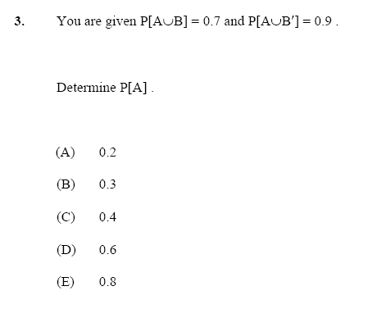

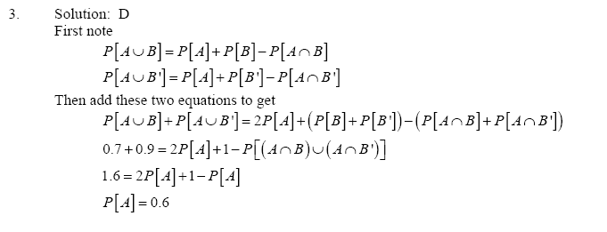

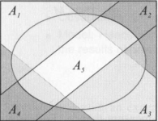

Collectively exhaustive iff (if and if only)



Shorthand notations for **unions** and **intersections**



De Morgan’s Law





**“The values of Probability is [0 ~1]”**

1.2 Applying set theory to probability

|  |  |
| --- | --- |
| **Set Algebra** | **Probability** |
| Universal set | Sample space |
| Set | Event |
| Element | Outcome |

* A **Sample space** of experiment is the finest grain, mutually exclusive, collectively exhaustive set of all possible outcomes.
* An **Event** is a set of outcomes of an experiment.
* An **Outcome** of an experiment is any possible observation of that experiment.
* **Event space** is a collectively exhaustive, mutually exclusive set of events

Ex] Flip a coin and let it land on a table

* Sample space 
* Outcomes are  and 

Ex] Flip a coin three times and

1. Observe the sequence of heads and tails.
2. Observe # of heads.

What is the sample space of each

* 
* 

**Quiz 1.2**

Monitor three consecutive phone calls going through a telephone switching office. Classify each one as a voice call  if someone speaking or a data call  if the call is carrying a modem or fax signal. Your observation is a sequence of three letters (ex. vvd or ddd…).

**Write the elements of the following sets.**

1.  2. 

3.  4. 

5.  6. 

7.  8. 

For each pair of events and so on, identify whether the pair of events is either **mutually exclusive** or **collectively exhaustive** or both.

1.  2. 

3.  4. 

5.  6. 

7.  8. 

 and  are mutually exclusive then 

 and  are collectively exhaustive then 

1.3 **Probability of Axioms**

**A probability measure  is a function that maps event in the sample space to real numbers such that**

* For any events , 
* 
* For any countable collection  of mutually exclusive events



where the square bracket is the event

**Some consequence of the Axioms**

* 
* 
* For any  and  *(not necessary disjoint)*



* If , then 

Ex] Union of two **disjoint** events is



Ex] If  and  then



** Sometimes we will use the following notation



* For an experiment with sample space in which each outcome is **equally likely (uniformly distributed)**,



**Ex]** Roll a six-sided die in which all faces are equally likely.

1. What is the **probability** of each outcome?
2. Find the **probabilities** of the events: "Roll 4 or higher," "Roll an even number," and "Roll the square of an integer."

The probability of each outcome is



The probabilities of the three events are

* 
* 
* 